# Lab: While Loop

Test your tasks in the Judge system: <https://judge.softuni.org/Contests/4408>

## Numbers 1 to 100

Write a program that:

* Print the numbers from **1 to 100, each on separate line**

## Example Input / Output

|  |  |
| --- | --- |
| **Input** | **Output** |
| *(no input)* | 1  2  3  4  …  100 |

## Decreasing Numbers

Write a program that:

* Reads an integer number **N**
* Print the numbers from **N down to 1 (inclusively),** each on separate line

**Note:** N will always be bigger than 1.

## Example Input / Output

|  |  |  |  |  |  |  |  |
| --- | --- | --- | --- | --- | --- | --- | --- |
| **Input** | **Output** |  | **Input** | **Output** |  | **Input** | **Output** |
| 5 | 5  4  3  2  1 | 4 | 4  3  2  1 | 7 | 7  6  5  4  3  2  1 |

## Odd Number

Write a program to **enter an odd number:**

* + Read numbers from the console until an **odd number** is entered
  + Print the **odd** number as output

## Example Input / Output

|  |  |  |  |  |  |  |  |
| --- | --- | --- | --- | --- | --- | --- | --- |
| **Input** | **Output** |  | **Input** | **Output** |  | **Input** | **Output** |
| 2  4  8  **3** | 3 | **5** | 5 | 4  8  10  **23** | 23 |

## Sequence 2k + 1

Write a program to print a **sequence of numbers**:

* + The first number is **1**
  + Each next number is **2 times the previous number + 1**
  + Read an integer number **n** from the console – the max number
  + Print the **elements of the sequence (starting with 1)**, which are **≤ n**

## Example Input / Output

|  |  |  |  |  |  |  |  |
| --- | --- | --- | --- | --- | --- | --- | --- |
| **Input** | **Output** |  | **Input** | **Output** |  | **Input** | **Output** |
| 8 | 1  3  7 | 15 | 1  3  7  15 | 33 | 1  3  7  15  31 |

## Sum Digits

Write a program to **sum the digits** of given number:

* + Read an **integer positive number** from the console
  + **Sum** its **digits** and print the sum

**Example:** Thenumber is 3451. Digits sum is 3 + 4 + 5 + 1 = 13.

## Example Input / Output

|  |  |  |  |  |  |  |  |
| --- | --- | --- | --- | --- | --- | --- | --- |
| **Input** | **Output** |  | **Input** | **Output** |  | **Input** | **Output** |
| 5634 | 18 | 150 | 6 | 532 | 10 |

## Number In Range

Write a program to **read a number in the range [1 … 100]**:

* + Read **an integer number** from the console
  + Check if the number is in the **range [1 … 100]**
    - No (number is **NOT** in the range) 🡪 **read a new number**
    - Yes (number is **IN** the range) 🡪 **print the number** and the program **stops**

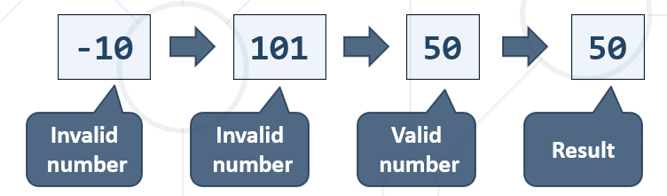

## Example Input / Output

|  |  |  |  |  |  |  |  |
| --- | --- | --- | --- | --- | --- | --- | --- |
| **Input** | **Output** |  | **Input** | **Output** |  | **Input** | **Output** |
| -10  101  50 | 50 | 150  -45  12 | 12 | 330  450  89 | 89 |

## Number Processor

Write a program to **process a sequence of commands**:

* + Read an **initial number** from the input
  + Read an execute a sequence of the following **commands**:
    - **"Inc"** – add 1 to the number (increment)
    - **"Dec"** – subtract 1 from the number (decrement)
    - **"End"** – print the number and stop the program

## Example Input / Output

|  |  |  |  |  |  |  |  |
| --- | --- | --- | --- | --- | --- | --- | --- |
| **Input** | **Output** |  | **Input** | **Output** |  | **Input** | **Output** |
| 5  Inc  End | 6 | 5  Dec  End | 4 | 7  Inc  Inc  Dec  End | 8 |